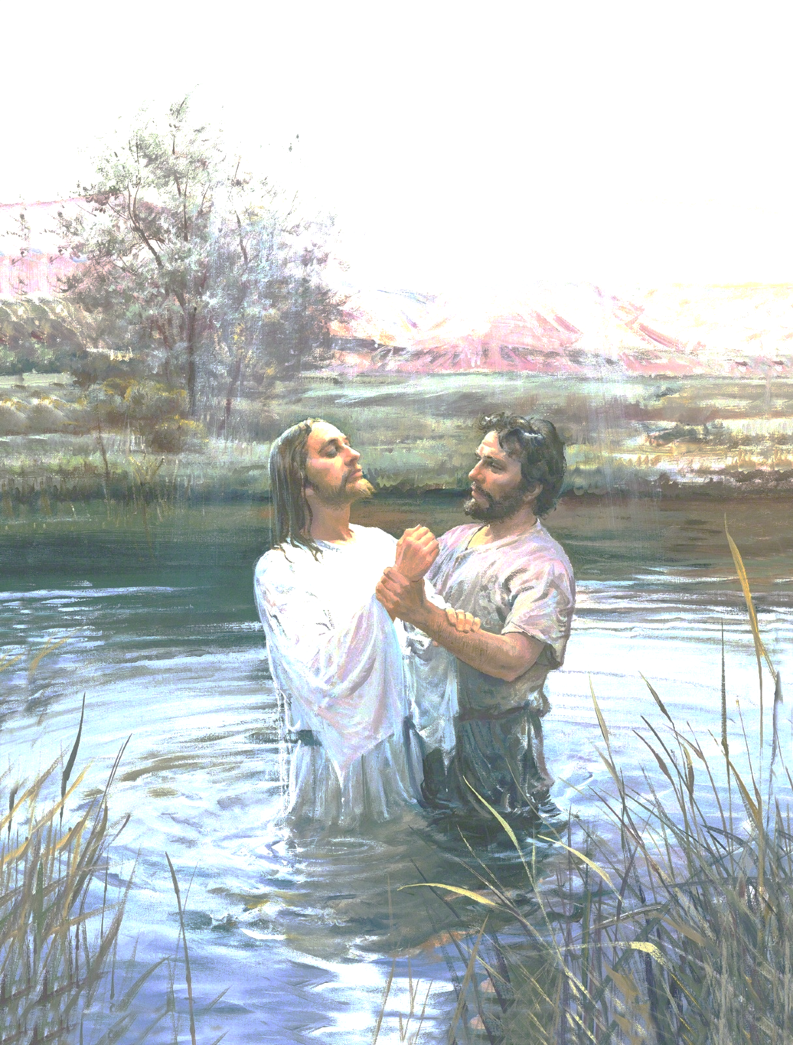
[Scripture or Song]

Welcome to the Baptism of

[Name]
[Date]

Presiding [Name]
Conducting [Name]
Pianist [Name]

Opening Song [Hymn] ([Number])
Invocation [Name]

Speaker [Name]

Baptism of [Name]

Speaker [Name]
Closing Remarks [Name]

Closing Song [Hymn] ([Number])
Benediction [Name]

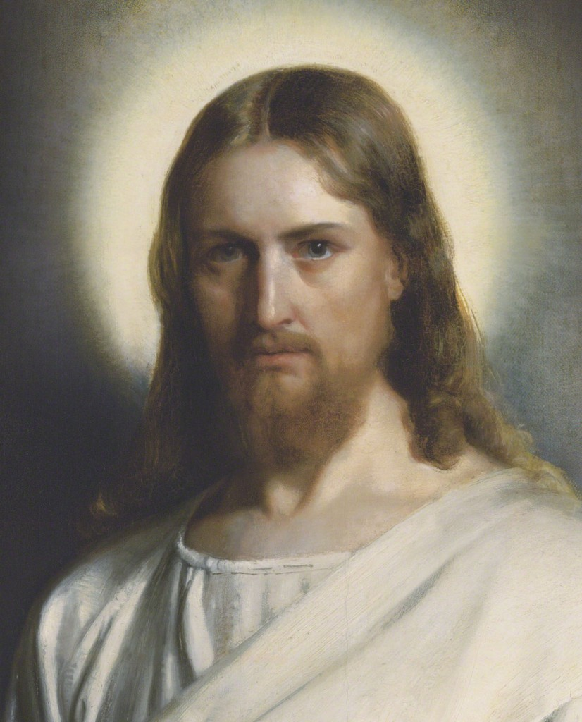

Wherefore, do the things which I have told you I have seen that your Lord and your Redeemer should do; for, for this cause have they been shown unto me, that ye might know the gate by which ye should enter.

For the gate by which ye should enter is repentance and baptism by water; and then cometh a remission of your sins by fire and by the Holy Ghost.

2 Nephi 31:17

